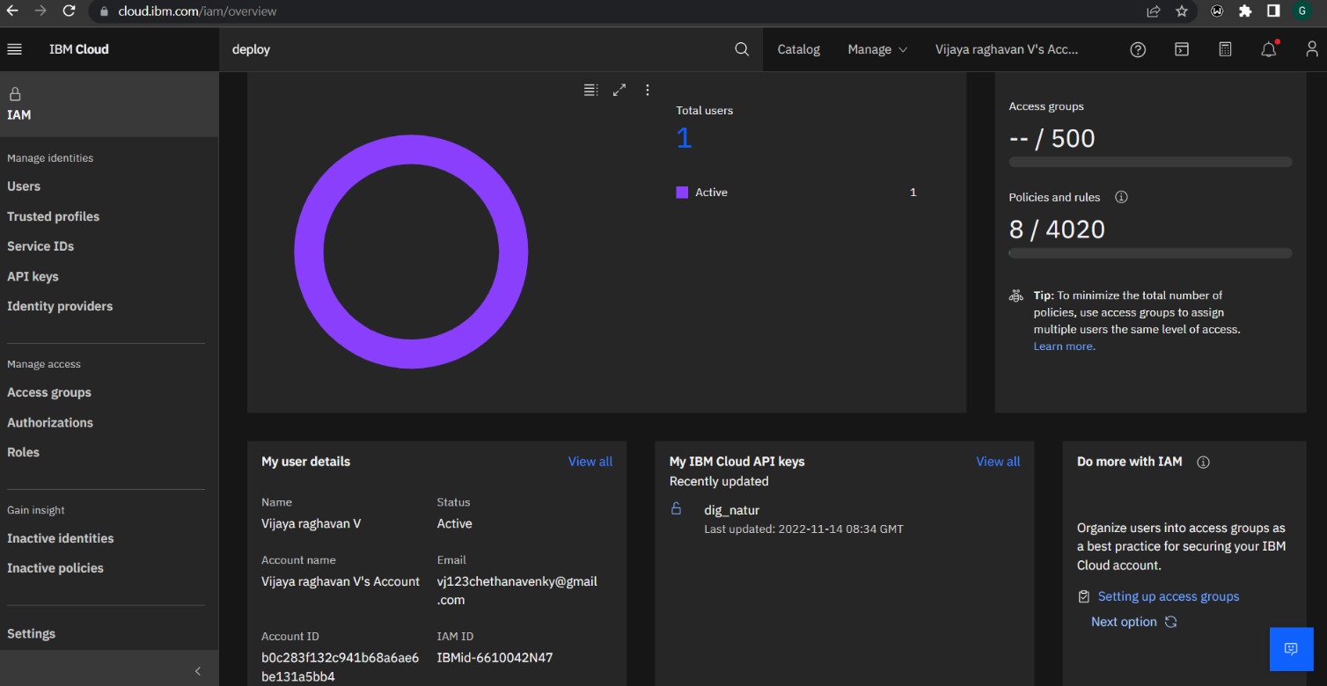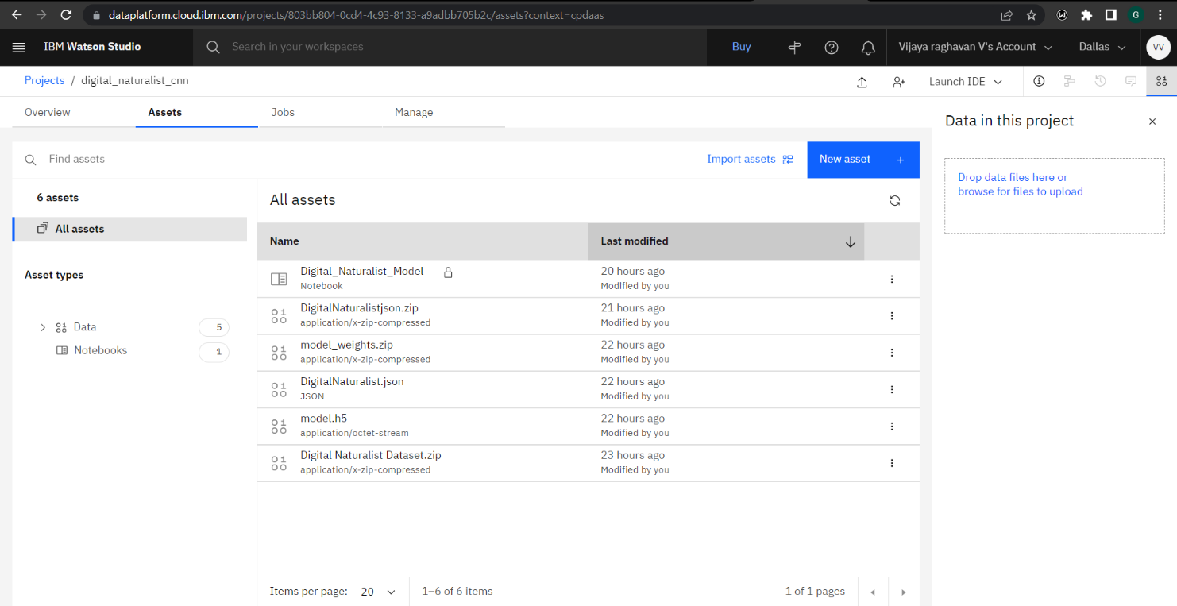**IBM CLOUD RE** **SOURCES**

